Week 7 Assessment
The overall code and annotation are in the last page.
1. Select a single metric from the data (e.g. age)
Ans: I will choose Q6: Estimate how many hours a week you spend in video chat (based on the last month) as my single metric.
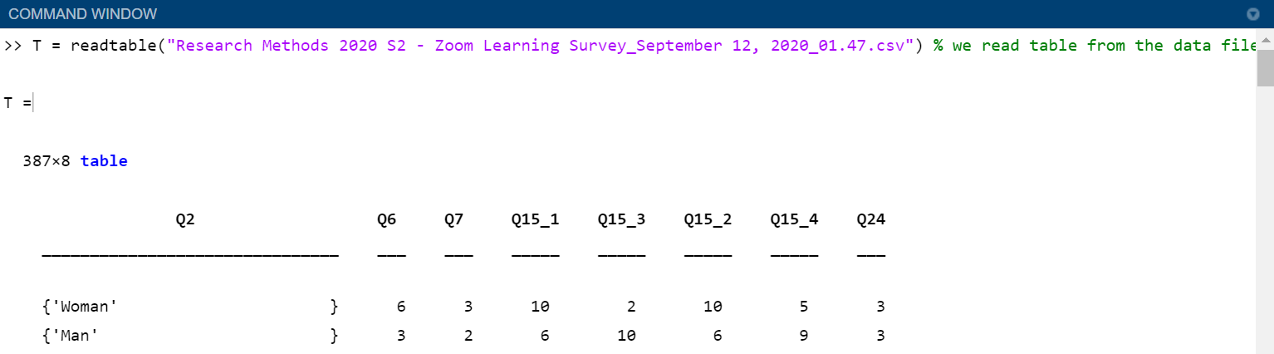
2. Population Standard Deviation & Interquartile Range
I found that there are some NaN values in this data set. Refer to https://edstem.org/courses/4484/discussion/297882 this thread, I will omit the NaN values.
Population Standard Deviation:
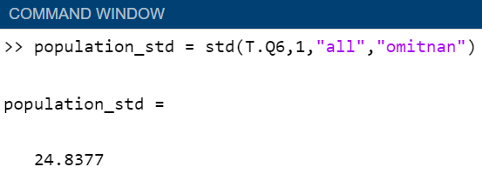
Explain:
% Calculate population standard deviation from the data set of Q6.
Population std means that this data is normalised by N, so the 2nd argument should be 1, rather than 0. Since we choose to ignore the NaN values, we can use the argument “omitnan” to omit them.
P.S. : MathWorks recommends us not to use nanstd() for some reason, so I use std() with “omitnan” instead.
Interquartile Range
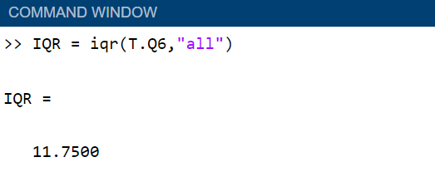
% Calculate the interquartile range of the data set of Q6.
3. Sample Standard Deviation
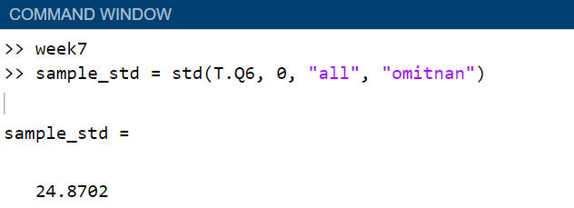
Sample standard deviation is calculated by std() with the normalization degree of n-1, which is 0(default) in the 2nd argument of std().
4. Plot
The assessment does not ask us to clean the data, but the data does have a few outliers. So, I will try to state the outliers.
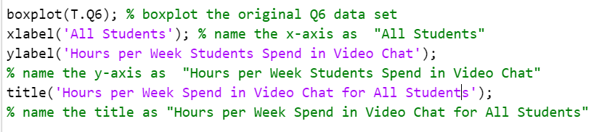
Result:
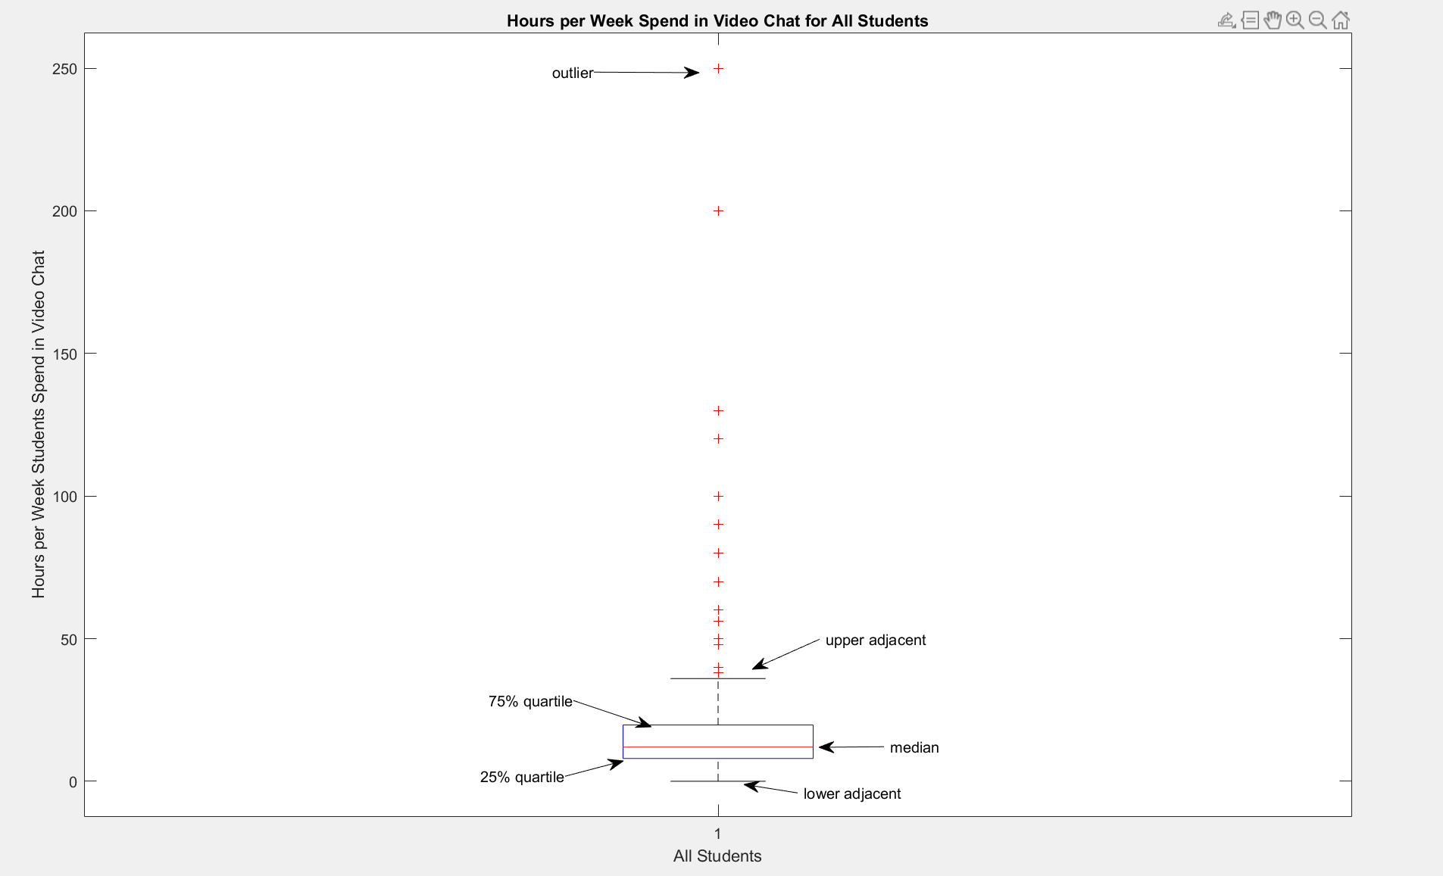
Clean data code:
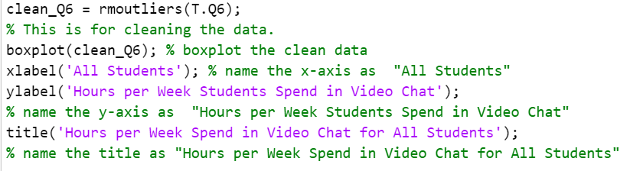
Result:
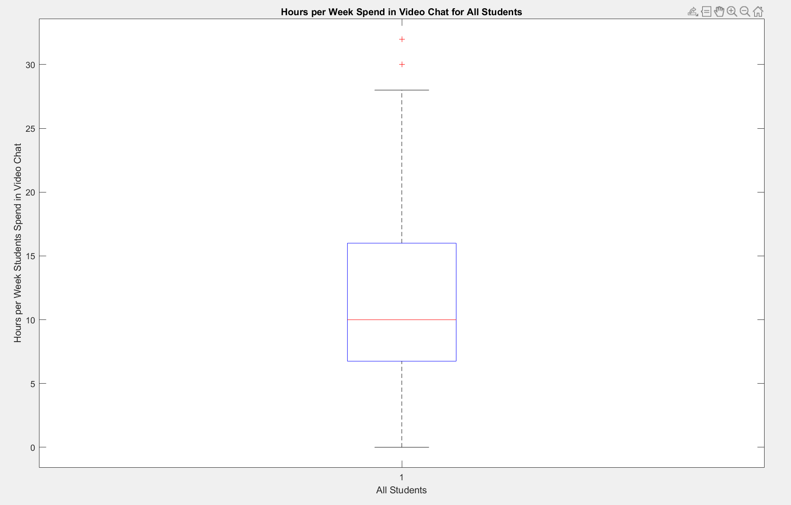
Overall MATLAB code:
